# Introduction

This paper outlines the group work conducted in an investigation that sought to improve the web browsing experience of the elderly. The report highlights the different parts of the project undertaken by each of the two group members involved in the project. Namely, Cole Noble and Kirti Nathoo. Following this, some of the graphs plotted by a version control system, *Github*,are given to provide one, an indication of the contributions of each individual to the project and two, the times as which most of the contributions occurred.

# Work division

The work division was broken down into two portions. The one portion being all graphically related adjustments that would be required. The second portion, all work relating to achieving voice recognition functionality on each webpage.

Kirti:

* Created all test websites
* Worked on visual feedback techniques (investigated different forms of pop-ups)
* Formatted surveys used for testing

Cole:

* Looked into how voice functionality would be achieved
* Implemented client side processing which rendered web page annotations, setup API vocabulary, and initiation of voice recognition using key presses and processing the server results.

The required functionality for each iteration was discussed extensively prior to the commencement of each iteration. The requirements for each survey were also jointly discussed so as ensure that each survey included both:

* Questions and space that would adequately assess the features incorporated into each iteration
* Present questions that would add additional guidance as to the course of consecutive iterations or highlight additional problems that needed to be considered

# Tracked information by the repository

*Git* was used as the version control tool for this project (1). This helped ensure that group work did not diverge in direction, that work could be easily merged and lastly, that there was a safety net for rolling back to prior working versions of the project (if a version became corrupt). *Git* was used in conjunction with *Github* (1)*,* a central server, to maximise the mentioned benefits of distributed version control. *Github* tracks various aspects of work committal the central server. One of the aspects it keeps track of is the relative amount of contributes to the server from each individual. Below, in Figure 1, is a graph indicating the relative contributions of each individual. The red and yellow highlighting indicates contributions by Cole Noble while the orange highlighting, committals by Kirti Nathoo.

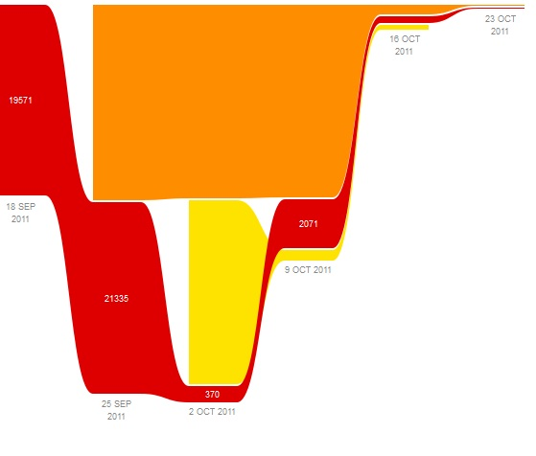

Figure 1: Repository contribution with time. Yellow and Red are Cole Noble's contributions, Orange is Kirti Nathoo’s contribution.

Cole Noble committed 61 times to the repository, contributed 42584 additions, and performed 10585 deletions. Kirti Nathoo committed 49 times, contributed 43627 additions and performed 40901 deletions from the project.

*Github* also tracks the commit activity by day and hour. Since much of the work was completed by working together at Wits University, most of the committals were done during the day. See Figure 2 below for the a graph indicating the amount of committal activity for the duration of the project.

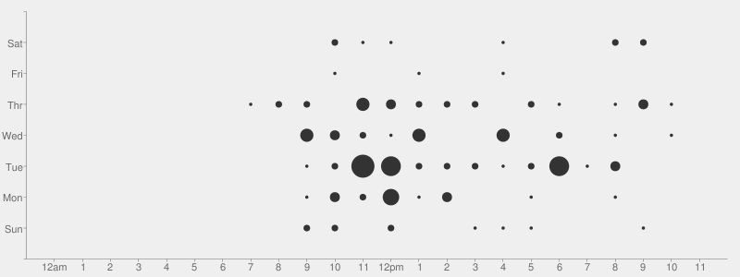

Figure 2: Majority of contribution times

# Conclusion

The preceding paper has discussed in brief the contributes of Cole Noble and Kirti Nathoo to an investigation which sought to find methods of improving the web browsing experience of the elderly. Kirti Nathoo was responsible the visual aspects of each test that was conducted and Cole Noble worked on the functionality. A distributed version control system, *Git,* was used to aid the cohesion of group work. Statistics from *Github* indicate that each member contributed a roughly equal amount of work to the project and that most work contributions took place during the day on weekdays.

# Bibliography

1. **Chacon, Scott.** Git -the fast version control system. *Git is.* [Online] 2011. [Cited: 26 October 2011.] http://git-scm.com/.

2. **GitHub Inc.** Github Social Coding. [Online] 2011. [Cited: 26 October 2011.] http://git-scm.com/.